**IDEATION PHASE**

**DEFINE THE PROBLEM STATEMENTS**

|  |  |
| --- | --- |
| **Date** | **03 NOVEMBER 2023** |
| **Team ID** | **NM2023TMID04737** |
| **Project name** | **A CRM APPLICATION FOR MANAGEMING LOAN APP AND FRADULENT PREVENTION** |
|  |  |

**A CRM APPLICATION FOR MANAGEMING LOAN APP AND FRADULENT PREVENTION**

|  |  |  |  |  |  |
| --- | --- | --- | --- | --- | --- |
| **Problem statements**  **(ps)** | **I am** | **I'm trying to** | **But** | **Because** | **Which makes me feel** |
| **Ps-1** | CUSTOMER | I am trying to identify the specific functionality, data requirements, user roles, and integration needs | But provide training to users and create documentation to guide them on how to use the CRM application effectively. | Because implement robust security measures to protect sensitive data and prevent unauthorized access. | Which makes me feel the CRM application streamlines loan application processes, automates tasks, and reduces the time required for approval, customers are likely to have a positive experience |

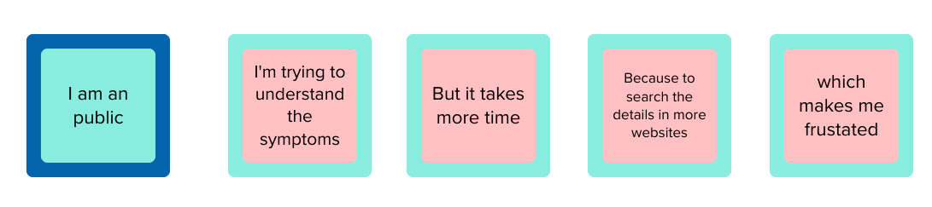

CUSTOMER

I am trying to identify the specific functionality, data requirements, user roles, and integration needs

But provide training to users and create documentation to guide them on how to use the CRM application effectively

Which makes me feel CRM application streamlines loan application processes, automates tasks,and reducesthe time

Because implement robust security measures to protect sensitive data and prevent unauthorized access.